**CSE3215**

**Quiz 4**

**Time: 30 minutes**

**Marks: 10**

| **1.** | **Suppose two Arduino boards are programmed to communicate with one another in a ‘MasterReceiver/SlaveWriter’ configuration via the I2C synchronous serial protocol. Draw the schematic diagram and write appropriate code for transmission.** | **[5]** |
| --- | --- | --- |
| **2.** | 1. **A sound wave created by an underwater ultrasonic sensor takes 734 milliseconds to hit an object placed 1200 meter away from the sensor. What is the speed of underwater sound?** 2. **If an object is placed 700 meters front of another ultrasonic sensor, what will be the total time the sensor gives a reading in air medium? Consider the speed of the sound in air medium 344 meters per second.** | **[5]** |

Solution 1:

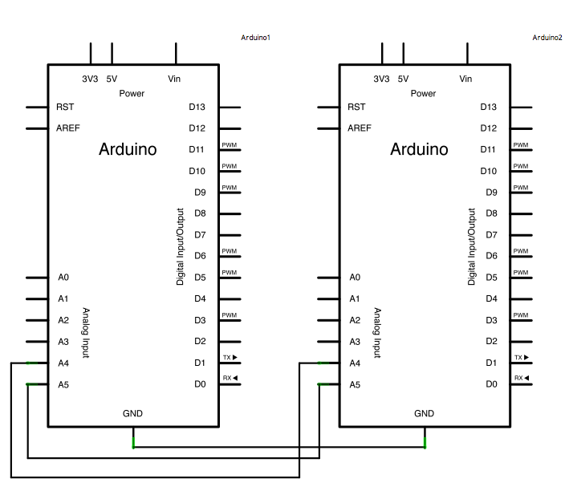

**Code for Master Reader - Program for Arduino 1**

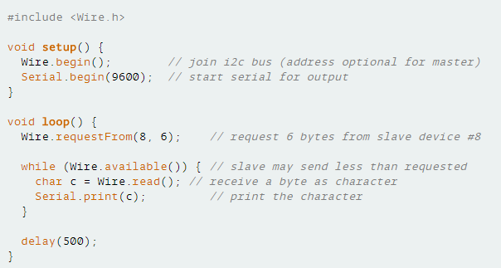

**Code for Slave Sender - Program for Arduino 2**

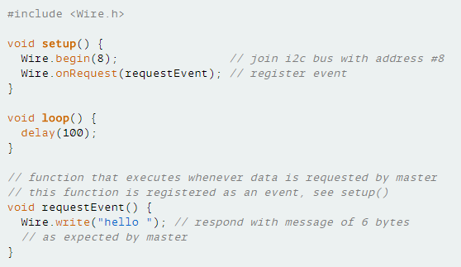

Solution 2:

1. v = s/t

1200m/0.734s = 1634 m/s

1. t = 2s/v

(2*700)s/344m/s= 4.07s